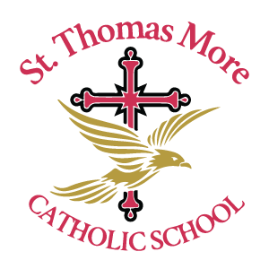

| ***SECUNDARIA LIST DE ÚTILES***  ***MIDDLE SCHOOL SUPPLY LIST 2025-2026*** | |
| --- | --- |
| 1 caja de lápices de colores | 1 box of colored pencils |
| 1 caja de marcadores | 1 box of washable markers |
| 2 botellas de pegamento | 2 glue bottles |
| 6 barras de pegamento | 6 glue sticks |
| 2 paquetes de #2 lapices -48 | 2 pack of #2 pencils -48 |
| 1 par de tijeras | 1 pair of scissors |
| 1 caja de borradores para lápices | 1 box of pencil cap erasers |
| 1 12” Regla In. & Cm | 1 12” Ruler In. & Cm |
| 2 borradores grandes rosados | 2 large pink erasers |
| 1 cuaderno negro - Matemeticas  1 cuaderno rojo-Lectura y Escritura  1 cuaderno azul - Estudios Sociales  3 cuadernos verdes - Ciencias | 1 Black Notebook - Math  1 Red Notebook- Reading and Writing  1 Blue Notebook- Social Studies  3 Green Notebook - Science |
| 1 Folder Negro - Matematicas  1 Folder Rojo- Lectura y Escritura  1 Folder Azul - Estudios Sociales  3 Folder Verdes- Ciencias | 1 Black Folder - Math  1 Red Folder- Reading and Writing  1 Blue Folder- Social Studies  3 Green Folder- Science |
| 3 contenedores de clorox wipes | 3 containers of large clorox wipes |
| 3 cajas grandes de Kleenex | 3 boxes of large Kleenex |
| 1 paquete de papel para copiar | 1 ream of copy paper |
| 1 botella de agua reusable | 1 reusable water bottle |
| 1 par de audífonos | 1 pair of headphones only or ear buds |
| 1 botella de Hand Sanitizer | 1 bottle of hand Sanitizer |
| 1 caja para lápices | 1 pencil case box or zip bag |
| 1 Mochila | 1 backpack |
| 1 par de zapatos para educación physica | 1 pair of tennis shoes to be kept at school for PE |
| 1 caja de Ziplock Quart - Apellido A-I  1 caja de Ziplock Gallon - Apellido J-Q  1 caja de Ziplock Sandwich - Apellido R-Z | 1 box Ziplock Quart - Last names A-I  1 box Ziplock Gallon - Last names J-Q  1 box Ziplock Sandwich - Last names R-Z |